 CHEMICAL ENGINEERING TRANSACTIONS  VOL. xxx, 2026 | A publication of  
The Italian Association
of Chemical Engineering
Online at www.cetjournal.it

Guest Editors: Marco Bravi, Antonio Marzocchella, Giuseppe Caputo
Copyright © 2026, AIDIC Servizi S.r.l.
ISBN 979-12-81206-xx-x; ISSN 2283-9216

Combined Exploitation of Chitosan Hydrogel and Laccases, for the Removal of Dyes from Textile Industry Wastewaters
Domenico Pirozzi ^{a,b}, Moreno Rizzo ^{b}, Wu Li ^{c}, Alessandro Latte ^{b}, Filomena Sannino ^{d}
ª CIRAM, University of Naples “Federico II”, Naples, Italy
^{b} DICMaPI, University of Naples “Federico II”, Naples, Italy
^{c} Hubei Polytechnic University, Huangshi, China
^{d} Department of Agricultural Sciences, University of Naples “Federico II”, Portici (Naples), Italy
dpirozzi@unina.it
The removal of synthetic dyes from textile wastewater is a critical environmental challenge. This study investigates the performance of chitosan-based materials, including plain chitosan, magnetic chitosan, and magnetic chitosan immobilized with laccase, for the removal of three representative textile dyes: Methylene Blue (MB), Bromophenol Blue (BPB), and Coomassie Brilliant Blue (CBB). The adsorption of dyes onto plain chitosan was strongly pH-dependent, governed by electrostatic interactions between dye molecules and chitosan functional groups. Increasing pH enhanced MB adsorption, while reducing the uptake of the anionic dyes BPB and CBB. Incorporation of iron oxide nanoparticles significantly improved adsorption capacity by increasing surface area and introducing additional interaction mechanisms. Further enhancement was achieved through laccase immobilization, which increased dye removal at all investigated pH values, with the most pronounced effect under acidic conditions (pH 5.0–7.0), consistent with the optimal catalytic activity of the enzyme. Reusability tests demonstrated good operational stability, with approximately 60% of the initial dye removal efficiency retained after 12 cycles, highlighting the potential of this system for sustainable textile wastewater remediation.
  - Introduction
Industrial activities are a major source of hazardous contaminants in wastewater, particularly in sectors such as pharmaceuticals, petrochemicals, food processing, and textiles. These effluents contain complex mixtures of organic and inorganic compounds, including toxic and recalcitrant substances that are difficult to remove using conventional treatment technologies. Among these sectors, the textile industry is one of the largest contributors to water pollution due to its high water consumption and extensive use of synthetic chemicals. Textile wastewater is typically characterized by high chemical oxygen demand (COD), biological oxygen demand (BOD), salinity, and strong coloration, making its treatment particularly challenging.
Among the most problematic pollutants are synthetic dyes released from textile and printing industries. These compounds are chemically stable, resistant to degradation, and highly visible even at low concentrations. Their presence in water bodies inhibits light penetration, reducing photosynthetic activity and negatively affecting aquatic ecosystems (Zhang et al., 2019). Moreover, many dyes and their degradation intermediates are toxic, mutagenic, or carcinogenic, posing serious risks to environmental and human health.
To address these challenges, various wastewater treatment strategies have been developed. Conventional methods, including membrane filtration, coagulation/flocculation, chemical precipitation, and biological degradation, are often energy-intensive, inefficient at high organic loads, or generate toxic by-products (Rashid et al., 2021; Kumar et al., 2023). Biological processes are cost-effective but limited by the low biodegradability of many dyes (Aragaw et al., 2024), while physicochemical methods, although more efficient, often involve high operational costs (Hasingler et al., 2016) and secondary pollution such as sludge generation (Yang et al., 2024).
Recently, advanced treatment technologies have emerged as promising alternatives, including advanced oxidation processes (AOPs) such as photocatalysis, Fenton-based reactions, ozonation, and electrochemical oxidation, which can degrade complex organic pollutants. Adsorption using activated carbon, biochar, and nanostructured materials has also been widely explored due to its simplicity and effectiveness. In addition, hybrid systems combining biological, physical, and chemical processes have shown improved performance in treating complex textile effluents.
Despite these advances, challenges related to scalability, cost-effectiveness, and environmental sustainability remain. Therefore, there is a growing need for innovative and eco-friendly treatment approaches capable of efficiently removing toxic compounds from industrial wastewater, particularly from the textile sector, while minimizing energy consumption and secondary pollution.
Adsorption has emerged as an effective and low-cost alternative for dye removal from wastewater (Pirozzi and Sannino, 2014; Di Martino et al, 2015; Stoller et al., 2019; Sannino et al., 2022; Satyam et al., 2024; Hu et al., 2025). In this context, chitosan has attracted considerable interest as an adsorbent due to the presence of hydroxyl (–OH) and amine (–NH₂) groups, which provide multiple adsorption sites and allow chemical modification. Chitosan is derived from chitin, an abundant by-product of seafood processing, making it a sustainable material consistent with circular economy principles. To improve its performance and facilitate recovery, chitosan has been modified with various additives, including iron oxide nanoparticles, to produce magnetic composites.
Chitosan-based hydrogels are promising adsorbents, offering enhanced porosity, mechanical stability, and adsorption capacity compared to native chitosan (Pandey et al., 2020). Their properties can be further improved by incorporating functional additives or using them as matrices for enzyme immobilization. Although chitosan hydrogels have been explored as supports for laccase immobilization (Naghdi et al., 2019), these studies mainly focused on antibacterial applications, leaving their potential for integrated pollutant removal comparatively underexplored.
In this study, a novel hybrid system combines the adsorption capability of chitosan hydrogels with the catalytic activity of immobilized laccase, enabling simultaneous removal and degradation of textile dyes. This dual-function approach integrates two complementary mechanisms in a single material platform. The hydrogel matrix enhances dye uptake and provides a stable environment for enzyme immobilization, improving laccase stability, reusability, and operational efficiency. Magnetic properties further allow rapid recovery of the biocatalyst, addressing a key limitation in enzyme-based treatments.
The system’s effectiveness is demonstrated on three representative textile dyes, Methylene Blue, Bromophenol Blue, and Coomassie Brilliant Blue, highlighting its versatility toward structurally diverse pollutants. Compared to conventional methods, this approach reduces the need for harsh chemicals, minimizes secondary pollution, and offers a more sustainable and scalable solution for complex industrial effluents.
From a broader perspective, this work advances environmentally friendly wastewater treatment technologies aligned with green chemistry and circular economy principles. The approach supports the United Nations Agenda 2030 Sustainable Development Goals (SDGs), particularly SDG 6 (Clean Water and Sanitation) by efficiently removing hazardous contaminants, and SDG 12 (Responsible Consumption and Production) by promoting sustainable industrial processes. By addressing key challenges in pollutant removal efficiency, material reusability, and process sustainability, this study provides a meaningful step toward next-generation treatment systems for textile wastewater.
  - Material and Methods
    - Materials
Low molecular-weight chitosan (average molecular weight: 110000, average deacetylation degree: 75%), laccase from Aspergillus spp., Methylene Blue (MB), Bromophenol Blue (BPB), Coomassie Brilliant Blue (BB), ABTS [2,2’-azino-bis-(3- ethyl-benzthiazoline-6-sulfonic acid)], hydroxybenzotriazole (HBT) and all the remaining reactants were purchased from Sigma-Aldrich. All reactants used were analytical grade.
    - Synthesis of the chitosan hydrogel
Chitosan (2% w/v) was added to a 1% acetic acid solution, and completely dissolved by a 3 h stirring. The solution obtained was added dropwise, using a 1-mm diameter syringe, into a solution of methanol in HCl (20:1 v/v) containing 1% glutaraldehyde. The hydrogel beads obtained were removed by filtration and used for adsorption experiments.
    - Adsorption of dyes by chitosan hydrogel
The adsorption of dyes was carried out at solid/liquid (S/L) ratio of 1/100. In each experiment, 5 ml of dye solution, usually at the concentration of 10 mg/L, were inserted in a 10 ml tube and inserted in an orbital stirrer at 37°C. Subsequently, 50 mg of chitosan hydrogel particles were added to the solution and kept under stirring (100 rpm).
At different time intervals, samples were uptaken. The chitosan particles were separated by filtration under vacuum, and the optical density of the solution was measured by a spectrophotometer (Shimadzu UV 1700).
The concentration of each dye before and after the adsorption tests was obtained by absorbance measurement at fixed wavelength values, namely: 668 nm for MB, 590 nm for BPB and 583 nm for BB.
    - Determination of laccase activity
The enzymatic activities of free and immobilized laccase were determined by monitoring the oxidation of 2,2’-azino-bis-(3-ethyl-benzthiazoline-6-sulfonic acid) (ABTS) to its cation radical (ABTS⁺) at 420 nm. The molar extinction coefficient of ABTS⁺ is 36,000 L/(mol cm).
In a typical test, 5 ml of ABTS substrate solution at 5 mM concentration in a 100 mM buffer at a given pH were inserted in a 10 ml tube. The reaction was started by addition of 0.5 ml of laccase solution at given pH and concentration. The reaction was usually carried out in an orbital stirrer (100 rpm) at 37°C. One unit of laccase activity unit was defined as the amount of laccase required to convert 1 μmol of ABTS substrate per minute under assay conditions.
    - Immobilization of laccase on chitosan hydrogel
The immobilization of laccase on chitosan hydrogel particles was carried out by adsorption. However, as glutaraldehyde crosslinking was carried out for the synthesis of chitosan hydrogels, partially unreacted glutaraldehyde molecules may have contributed to increase the enzyme immobilization. Consequently, the actual mechanism of the laccase immobilization could be described as adsorption/covalent binding. In a typical test, 10 mg of laccase were dissolved in 20 ml of Na-phosphate buffer solution. Subsequently, 200 mg of chitosan particles were added to the solution, and kept under gentle stirring (60 rpm) for 24 h at 4°C. It has been previously ascertained that 24 h are sufficient for the adsorption equilibrium to be reached. At the end of the adsorption processes, the chitosan particles were separated by filtration under vacuum and washed 3 times with Na-acetate buffer, then dried at room temperature.
    - Repeated adsorption cycles
The reusability of the laccase immobilized on chitosan was investigated by carrying out the degradation tests at 37°C. After each cycle, the enzyme was washed with acetate buffer at the same pH used for the degradation test, and separated by centrifugation (5000 rpm, 10 min), to be subsequently reused.
  - Results and Discussion
    - Magnetic chitosan without laccase
The experimental activity was aimed to evaluating the potential of magnetic chitosan, with and without laccase, in the removal of three dyes commonly used in the textile industry:
      - Methylene Blue (MB) is a cationic dye, containing a quaternary ammonium structure that remains positively charged.
      - Bromophenol Blue (BPB) is an anionic, sulfonephthalein dye that loses protons and carries a negative charge at neutral–alkaline pH.
      - Coomassie Brilliant Blue (CBB) is anionic dye containing a sulfonic acid groups that are dissociated and negatively charged at normal staining pH.
The adsorption of MB, BPB, and CBB onto plain chitosan hydrogel was found to be strongly dependent on the solution pH (Figure 1). Methylene Blue, a cationic dye, exhibited an increase in adsorption capacity with increasing pH, whereas both Bromophenol Blue and Coomassie Brilliant Blue, which are anionic dyes, showed a decrease in adsorption capacity as pH increased.
This behaviour can be explained by the surface charge characteristics of chitosan, which contains amine (–NH₂) and hydroxyl (–OH) functional groups. At low pH, the amine groups are predominantly protonated (–NH₃⁺), imparting a positive surface charge to chitosan. Under these conditions, adsorption of anionic dyes is favoured due to electrostatic attraction, while adsorption of cationic dyes is hindered by electrostatic repulsion. As the pH increases, the amine groups become deprotonated, reducing the positive charge on the chitosan surface. This shift enhances the adsorption of cationic dyes such as Methylene Blue through stronger electrostatic attraction, while adsorption of anionic dyes is reduced due to increased electrostatic repulsion.

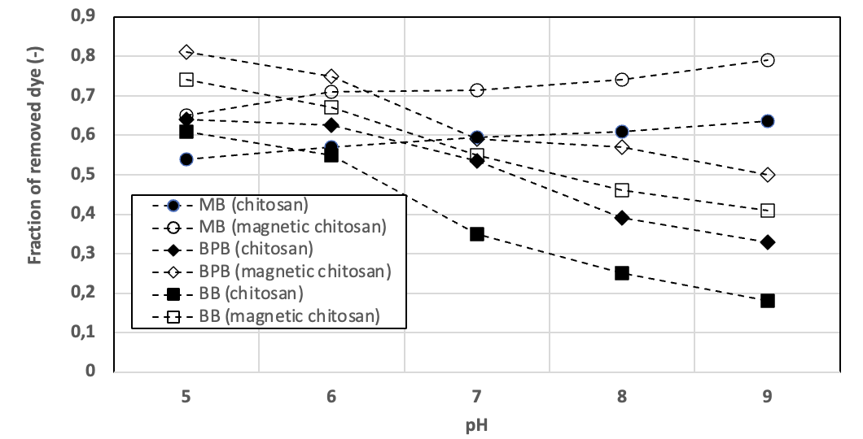
Figure 1: Effect of pH on the adsorption capacity of chitosan and magnetic chitosan
These findings are consistent with previous reports on pH-dependent dye adsorption onto biopolymer adsorbents, highlighting the critical role of electrostatic interactions in the adsorption process.
When replacing plain chitosan with magnetic chitosan (chitosan incorporated with iron oxide nanoparticles) an increase of the adsorption capacity was observed. This effect can be due to at least two reasons. First of all, iron oxide nanoparticles introduce additional surface area and porosity into the chitosan matrix. This provides more active sites for dye molecules to attach, increasing overall adsorption. In second place, iron oxide can interact with dyes through electrostatic interactions, hydrogen bonding, or coordination bonds.
For example, cationic dyes (like MB) can interact with negatively charged oxide surfaces at higher pH, and anionic dyes (like BPB or CBB) can form complexes or hydrogen bonds with surface hydroxyl groups on iron oxide. These interactions complement the adsorption by chitosan’s amine and hydroxyl groups.
    - Magnetic chitosan with laccase
Figure 2 compares the dye removal efficiency of magnetic chitosan in the presence and absence of laccase. The removal of MB increased in the presence of laccase at all investigated pH values. The experimental data indicate that the enzymatic effect is more pronounced under acidic conditions, particularly in the pH range of 5.0–7.0.
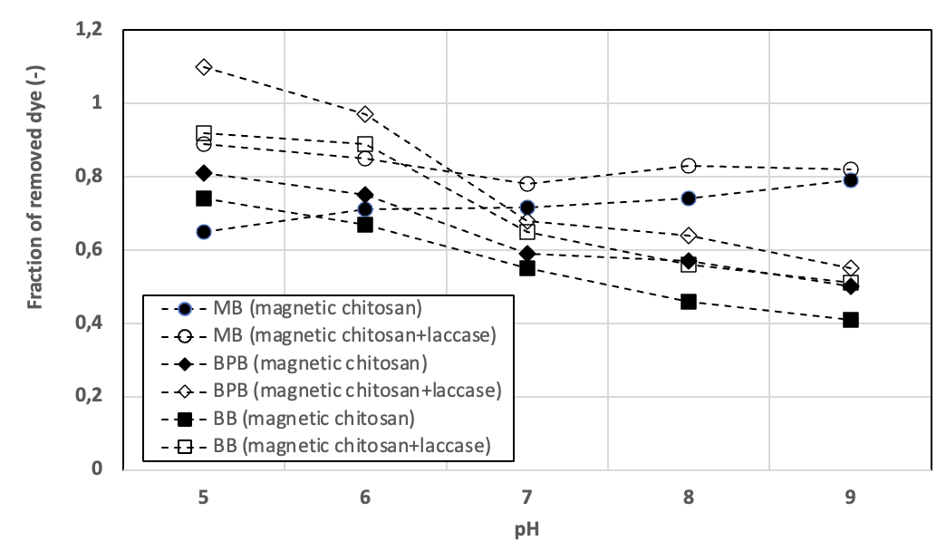
Figure 2: Effect of pH on the adsorption capacity of magnetic chitosan in the presence and in the absence of laccase

A similar trend was observed for BPB, for which the removal capacity also increased in the presence of laccase, with the enhancement being more significant under acidic conditions. Overall, these results confirm that laccase positively contributes to dye removal, especially at lower pH values.
In order to explain why the effect of the laccases is more pronounced under acidic conditions, the effect of the pH on the catalytic activity of non-immobilized laccase has been characterized. The experimental data in Table 1 indicate that the optimal pH of laccase activity is in the acidic range.
The adsorption efficiency of the enzyme on the magnetic chitosan has also been measured at different values of pH. The data in Table 1 show that the immobilization yield was strongly affected by pH, as well, and the maximum amount of immobilized enzyme was obtained under neutral pH values (about 7).
The improved effect of laccase under acidic pH values (see Figures 1 and 2) can be due to both factors, i.e. the intrinsic catalytic activity laccase and the adsorption efficiency. However, the results reported in the Table 1 demonstrate that the effect of intrinsic laccase activity is prevailing.
Table 1: Effect of pH on the catalytic activity of of non-immobilized laccase and the immobilization yield on magnetic chitosan
pH | Catalytic activity of non-immobilized laccase (fraction of max. activity) | Immobilization yield on magnetic chitosan (%)
3 | 0,95 | 25
4 | 1 | 29
5 | 0,92 | 42
6 | 0,79 | 65
7 | 0,75 | 78
8 | 0,68 | 71
9 | 0,57 | 44
    - Long-term stability of magnetic chitosan with laccase
An important aspect to evaluate the feasibility of the dye-removal application is the possibility of multiple reuse of the catalyst. As a matter of facts, the repeated use of the enzyme is a bottleneck still limiting the large-scale application of the laccase. In this view, we carried out multiple cycles of the dye degradation using magnetic chitosan with immobilized laccase, as shown in Figure 3.
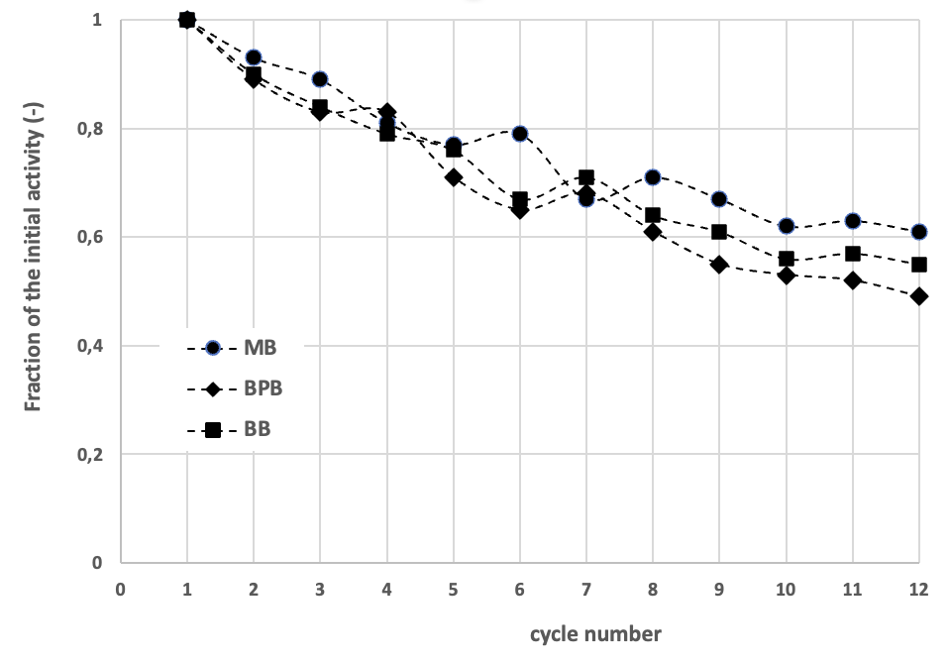
Figure 3: Multiple cycles of adsorption of dyes in the presence of magnetic chitosan with immobilized laccase.
The experimental data indicate a progressive decrease in the removed fraction of dyes, probably due to the leakage of the immobilized enzyme, to its long-term inactivation, or to the progressive saturation of the adsorption sites on the surface of the magnetic chitosan. Yet, about 60% of the initial removal rate was kept after 12 cycles, demonstrating the feasibility of the method in the remediation of the textile wastewaters.
  - Conclusions
Dye adsorption on plain chitosan was strongly influenced by solution pH, reflecting electrostatic interactions between dye molecules and chitosan functional groups. The incorporation of iron oxide nanoparticles significantly enhanced dye removal efficiency by increasing surface area and introducing additional interaction mechanisms, while also enabling magnetic separation. Further improvement was achieved by immobilizing laccase onto magnetic chitosan, resulting in enhanced dye removal across all tested conditions, particularly under acidic pH where the enzyme exhibited its highest catalytic activity. Although enzyme immobilization yield was favoured near neutral pH, catalytic activity was identified as the dominant factor governing dye degradation. Reusability tests demonstrated good operational stability, with approximately 60% of the initial removal efficiency retained after 12 consecutive cycles. Overall, the synergistic combination of adsorption and enzymatic catalysis provides a promising, sustainable strategy for wastewater remediation, offering effective dye removal, operational simplicity, and reuse potential.
Future work will focus on scaling up the system for continuous-flow treatment and exploring its effectiveness against a broader range of industrial dyes and real textile effluents. Additionally, optimizing enzyme loading, exploring alternative functional nanoparticles, and integrating this approach with complementary treatment processes could further enhance its practical applicability and sustainability.
References
Aragaw T.A., 2024, A review of dye biodegradation in textile wastewater, challenges due to wastewater characteristics, and the potential of alkaliphiles, Journal of Hazardous Materials Advances,16, 100493.
Di Martino M., Sannino F,, Pirozzi D., 2015, Removal of pesticide from wastewater: Contact time optimization for a two-stage batch stirred adsorber, J. Environ. Chem. Eng., 3, 365-372.
Haslinger J, Lindtner S, Krampe J., 2016, Operating costs and energy demand of wastewater treatment plants in Austria: benchmarking results of the last 10 years, Water Sci Technol., 74(11), 2620-2626.
Hu R., 2020, Pollution control and remediation of rural water resource based on urbanization perspective, Environmental Technology & Innovation, 20, 101136.
Hu, Q., Hao, L., 2025, Adsorption Technologies in Wastewater Treatment Processes, Water, 17, 2335.
Kumar M., Shekhar S., Kumar R., Kumar P., Govarthanan M., Chaminda T., 2023, Drinking water treatment and associated toxic byproducts: Concurrence and urgence, Environmental Pollution, 320,121009.
Li Y., Ye Q., Liu A., Meng F., Zhang W., Xiong W., Wang C., 2017, Seeking urbanization security and sustainability: Multi-objective optimization of rainwater harvesting systems in China, J. Hydrol., 550, 42-53.
Liu J., Yang H., Gosling S.N., Kummu M., Flörke M., Pfister S., Hanasaki N., Wada Y., Zhang X., Zheng C., 2017, Water scarcity assessments in the past, present and future, Earth's Future, 5, 545-559.
Naghdi M., Taheran M., Brar S.K., Kermanshahi-Pour A., Verma M., Surampalli R.Y., 2019, Fabrication of nanobiocatalyst using encapsulated laccase onto chitosan-nanobiochar composite, Int. J. Biol. Macromol., 124, 530-536.
Pandey S., Do J.Y., Kim J., Kang M., 2020, Fast and highly efficient removal of dye from aqueous solution using natural locust bean gum based hydrogels as adsorbent, Int. J. Biol. Macromol., 143, 60-75.
Pirozzi D., Sannino F., 2014, Design of a multi-stage stirred adsorber using mesoporous metal oxides for herbicide removal from wastewaters, J. Environ. Chem. Eng., 211-219.
Rashid R., Shafiq I., Akhter P., 2021, A state-of-the-art review on wastewater treatment techniques: the effectiveness of adsorption method, Environ. Sci. Pollut. Res., 28, 9050-9066.
Sannino F., Pansini M., Marocco A., Cinquegrana A., Esposito S., Tammaro O., Barrera G., Tiberto P., Allia P., Pirozzi D., 2022, Removal of sulfanilamide by tailor-made magnetic metal-ceramic nanocomposite adsorbents, J Environ Managem., 15, 114701.
Satyam S., Patra S., 2024, Innovations and challenges in adsorption-based wastewater remediation: A comprehensive review, Heliyon, 10(9), e29573.
Stoller M., Vuppala S., Cheng C., Traore M., Marchetti A., Kanaev A., Chiavola A., 2019, Design of Novel Equipment Capable to Quickly Produce Efficient Nanomaterials for Use in Environmental and Sanitary Emergencies, Chemical Engineering Transactions, 73, 187-192.
Strokal M., Croeze C., 2020, Water, society and pollution in an urbanizing world: recent developments and future challenge, Curr. Opin. Environ. Sustain., 46, 11-15.
Wang M., Ren J., Ding A., Zhao W., Zhao X., Liu W., Bai Y., Ren L., Wang S., Wen Y., Yang B., 2023. Water quality degradation drives the release and fractionation transformation of trace metals in sediment, Science of The Total Environment, 858(1), 159504.
Yang, S.J.; Eom, J.Y.; Lee, M.J.; Hwang, D.H.; Park, W.B.; Wie, Y.M.; Lee, K.G.; Lee, K.H., 2024, Comparative Environmental Evaluation of Sewage Sludge Treatment and Aggregate Production Process by Life Cycle Assessment, Sustainability, 16, 226.
Zhang H., Wu J.R., Wang X., Li X.S., Wu M.X., Liang F.Yang Y.W., 2019, One-pot solvothermal synthesis of carboxylatopillar[5]arene-modifed Fe₃O₄ magnetic nanoparticles for ultrafast separation of cationic dyes, Dyes Pigm., 162, 512-516.

